Columbia Weavers and Spinners’ Guild Membership Form

Membership year is from July 1 to June 30. Renewals not received by Aug. 15
will not be included in the guild directory.

Complete this form to register. An online registration form is available at: CWSGcomo.org or goo.gl/jIC62b

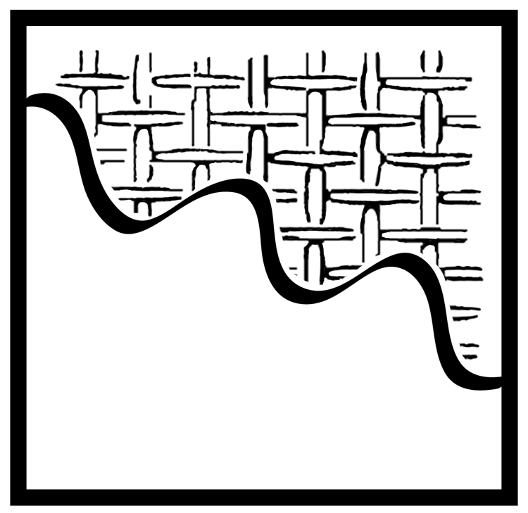
Make checks payable to CWSG. Mail to CWSG, P.O. Box 124, Columbia, MO 65205-0124,
or turn them in at a guild meeting.

Annual Membership - $35 Age 80+ Membership - Free (Registration required)

Guild Patron - $50 (Recommended) Limited Income - $10

Household Membership - $60 (Contact information and interests needed for each interested person.)

Magnetic name badges are ordered annually on Nov. 15.
To order a name badge, include an additional $10.
Please indicate clearly how your name should appear. ____________________________
Name ________________________________________________________
Renewing? Indicate changes only below:
Street Address __________________________________________________
City _____________________________ State ___________ Zip __________
home phone __________________ cellphone ________________________
email ________________________ ravelry.com username _____________
website(s) ____________________________________________________
Please indicate your fiber interests: |  | Other fiber interests:  ____________________________________  ____________________________________  Wool/fiber producers specify type(s) of fiber:  ____________________________________  It takes many skills to keep us going. Please list your  special skill or interests – management, accounting,  fundraising, teaching, PR, social media/web, etc.  Thanks!  ____________________________________  ____________________________________
   WEAVING   Basketry   Bead weaving   Basic weaves   Computers & looms   Multi-shaft   Rigid heddle   Tapestry   Triangle weaving |     Crocheting   Dyeing   Feltmaking   Knitting   Marketing   Needlework   Papermaking   Rug hooking   Spinning   Surface design

